

Mobile: +919844494796
Srivatsa k
`
Brief Description:
•
•
•
E-mail: cvatsa@gmail.com
Having an overall of 2.7 years of experience in development of scripts using scripting languages
like Python and Perl.
Experience in development of test automation frameworks.
Experience In automation development on NFS protocol.
Educational Qualification:
B.E (Computer Science) with an aggregate of 72.5% from CIT, Tumkur Karnataka.
Professional Experience
•
•
•
•
Working at HCL Technologies Ltd, as a Software Engineer in Bangalore from Nov’ 11 to till
date.
Worked at client location NetApp, Bangalore as a QA Engineer.
Having good understanding on Storage concepts for e.g.: (RAID, SAN, NAS, SCSI ISCSI,FC
Backup and Storage management )
Had training on Concepts of operating systems, Networking Concepts and protocols (TCP/IP,
ICMP, ARP, RARP).
Technical Skills:
Operating Systems
Languages
Network Protocol
Storage management software
Configuration Management Tool
Web Application Frameworks
:
:
:
:
:
:
Windows 7, Linux
Python, Perl, SQL.
NFS
SANtricity v 90.83
Perforce
Selenium v 2.25.
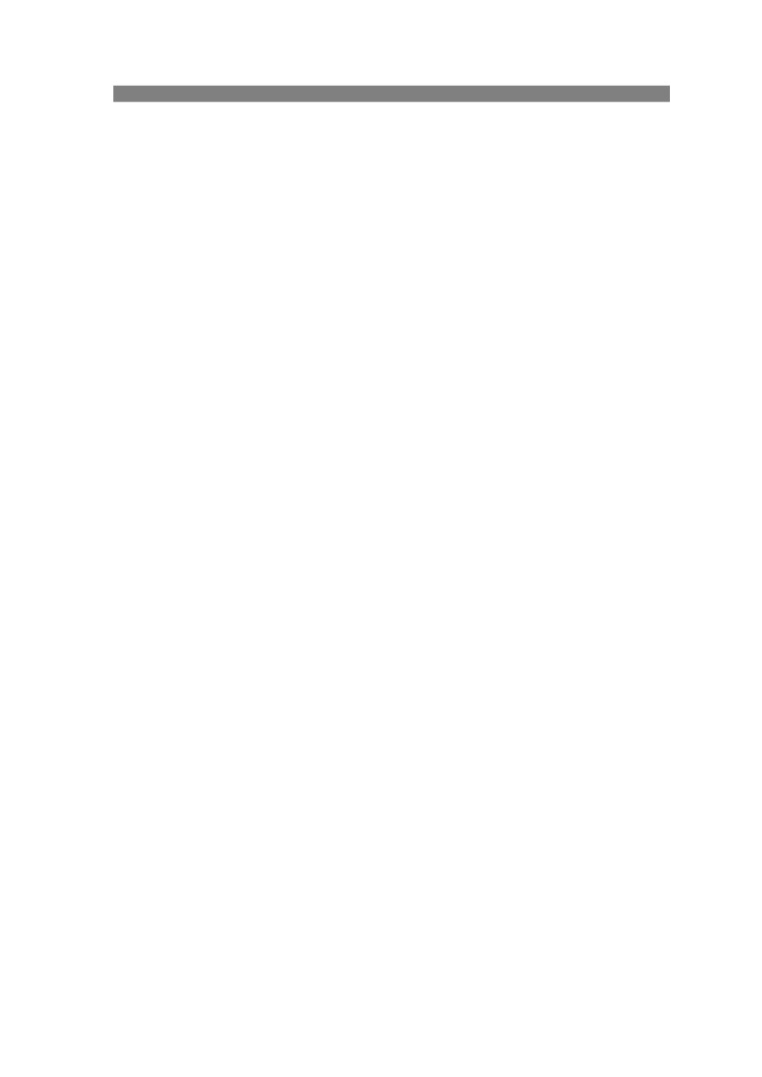
Project #1: NFS Locking and security automation
Client: NetApp, Inc.
Team size: 2
Platform: NFS, Perl, Python
Description:
The project was with respect to conversion of Python NFS file locking and security related
test cases to Perl equivalent. Along with new test cases development on multiprocessor, PNFS and
NSDB related functionalities
These include design and development of libraries in Perl and automate test cases on NFS related
functionality. The developed libraries and test cases are NACL (NetApp Central Library) compliant and
can be used for automating any related test cases, advantages, Usability, maintainability across
releases
Roles & Responsibilities:
1) Involved in the development of Perl equivalent for Python locking and security libraries.
2) Involved in design and development of test cases related to NFS locking and security.
3) Co-ordinate with the U.S Team members obtained requirements and got developed test
cases reviewed periodically.
4) Made libraries re-usable and easy adaptable.
Project #2: Code Health Web App Test Automation
Client: NetApp, Inc.
Team size: 3
Platform: Python, GCOV, LCOV & NCOV
Tools used: Selenium Web Driver, HTML Test Runner & Python Unittest
Description:
The project was with respect to design and development of test automation framework
using python with python selenium webdriver bindings and uses this framework to automate the test
cases of the Code Health Web App Automation.
The developed framework can be used in automating the test cases of any kind of web application.,
and it displays the statistics of how much code has been covered in a source file (or percentage of
code been touched), to have this metrics displayed, and different open source tools like gcov, lcov
were used.
Roles & Responsibilities:
1) Involved in the development of test automation framework
2) Involved in coupling of reporting mechanism, framework and unit test modules.
3) Enhanced the framework with features such as browser neutral automation, suite execution.
4) Made framework re-usable and easy adaptable.
5) Co-ordinate with the U.S Team members and obtain requirements
Project #3: SANtricity Test Automation
Client: NetApp, Bangalore
Team size : 5
Platform: Perl
Tools used: SANtricity, TestNG.
Description:
The software tool for which the test cases automation to be done was with respect to
storing and managing the data in storage arrays, in addition to this it had the functionality of storing
the data with different RAID levels, take snapshots of the data etc.
There were two kinds of interfaces through which the automation was carried out.
i) CLI (Command Line Interface)
ii) UI (User Interface)
Roles & Responsibilities:
1)
2)
3)
4)
Involved in development of both UI and CLI testing Framework.
Interacted with client to gather requirements.
Involved in enhancing the framework based on the client’s requirement.
Done unit testing on the framework and delivered this to testing team for test cases
automation
Personal Details:
Name: - Srivatsa K
Date of Birth: - 26-Sep-1989
Languages Known: - English, Kannada, Tamil & Hindi.
Residential Address: - No 15, “Sree Nilaya”,
Opposite to PWD Qtrs,
Edigha Mohalla,
Tumkur. 572101
Mobile:+91-9844494796
Place: Bangalore
Date:
Srivatsa K

